Sequence Diagram for NGO/SSI Management :

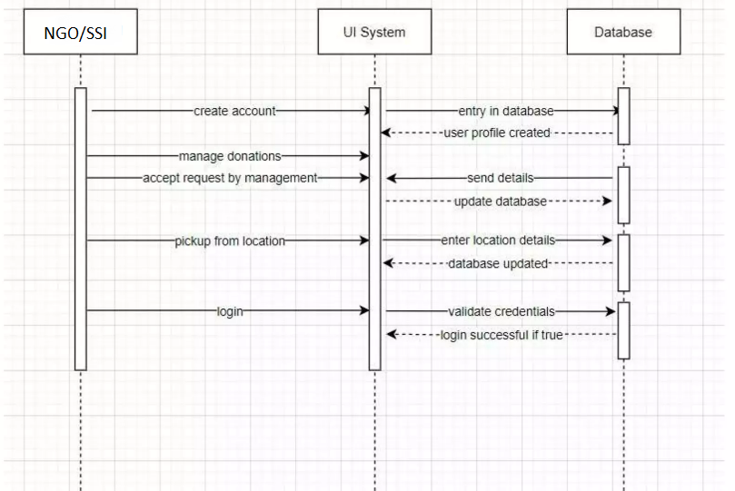

Sequence Diagram for User(Doner) :

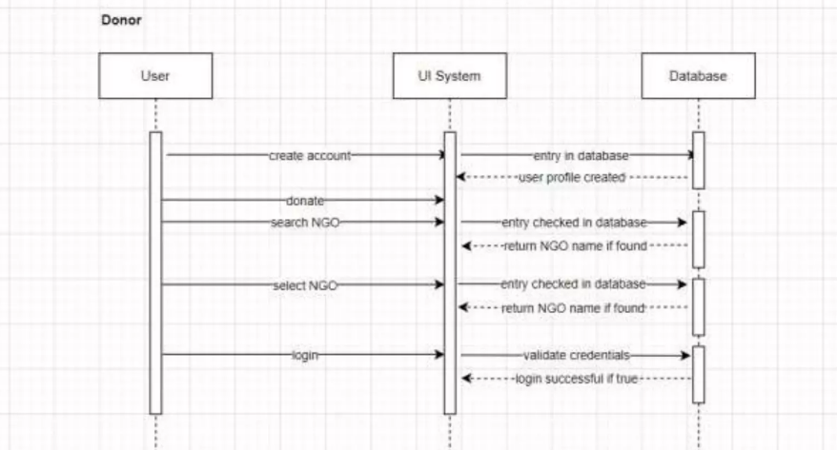

Activity Diagram For NGO/SSI :

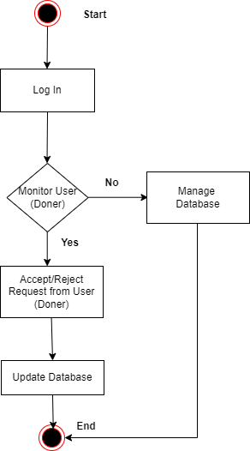

Activity Diagram For User (Doner) :

